Query the Name of any student in **STUDENTS** who scored higher than 75  Marks. Order your output by the last three characters of each name. If two or more students both have names ending in the same last three characters (i.e.: Bobby, Robby, etc.), secondary sort them by ascending ID.

**Input Format**

The **STUDENTS** table is described as follows: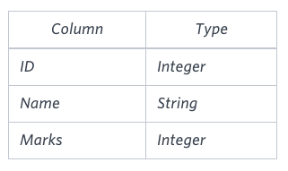

The Name column only contains uppercase (A-Z) and lowercase (a-z) letters.

Solution :

SELECT NAME

FROM STUDENTS

WHERE MARKS>75

ORDER BY SUBSTR(NAME,-3,3) , ID ASC;